Train Engineer Persona

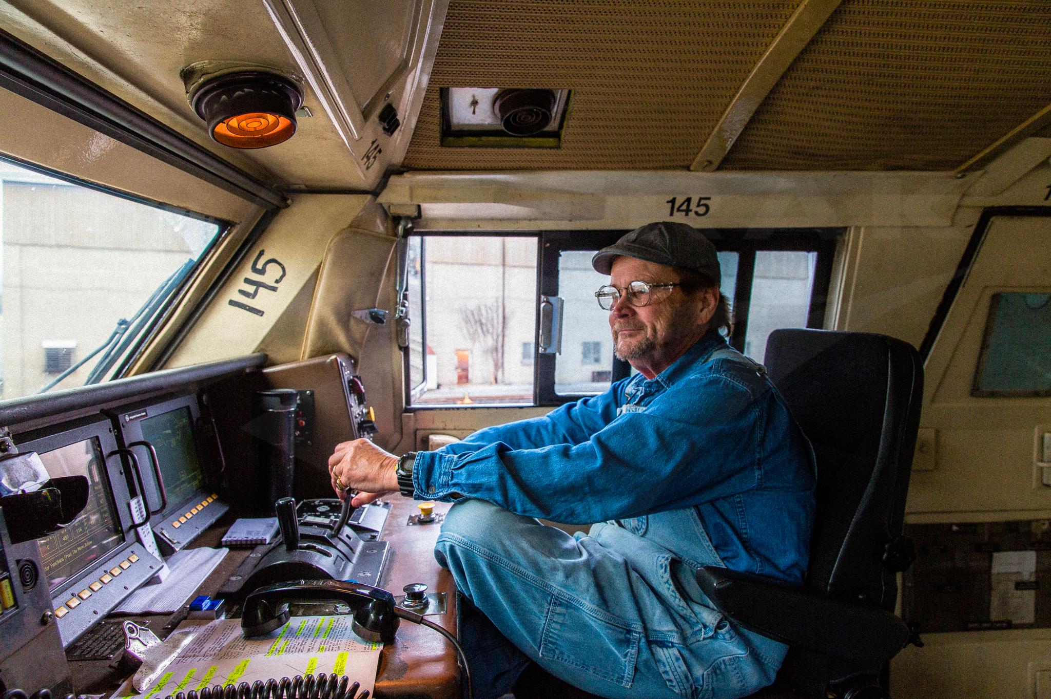

**Name:** Gregory McCaugh

**Age:** 45

**Residence :** Pittsburgh PA

**Occupation:** Train Engineer

**Biography(small description of user) :** Gregory has loved trains since he was a kid, and decided after college to pursue his passion of making sure trains were functioning correctly and spending all his time. He grew up in the Washington area but came to Pittsburgh to follow his wife's new job. He is deeply disappointed with the lack of Trains in Pittsburgh

**Education Level:** Bachelors Degree in Mechanical Engineering

**Salary Range:** $81,000 - 100,000

**Technology Comfort Level :** While Frank is comfortable with the technology of trains due to his job, he has a hard time learning other newer technology and sometimes struggles to navigate his iphone. He is more adapted than most people his age to modern technology but doesn't like new change.

**Hobbies :** Watching Sunday football, Sudoku, Walking his dog

**Goals :** Easy understandable Input for KI and KP and can very clearly see the outputted affect on the power of the train